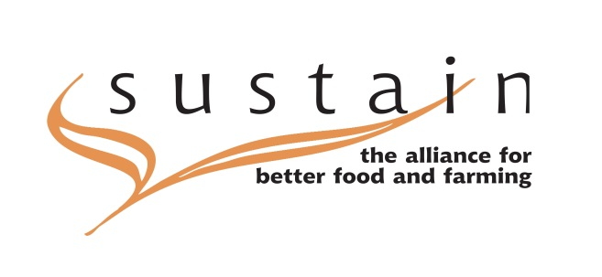
Sustain’s response to the consultation on
Local Welfare Provision
November 2014

About Sustain
Sustain: The alliance for better food and farming advocates food and agriculture policies and practices that enhance the health and welfare of people and animals, improve the working and living environment, enrich society and culture and promote equity. We represent around 100 national public interest organisations working at international, national, regional and local level. Amongst our projects and campaigns are:
- Sustainable Food Cities: which is a network of local food partnerships taking a holistic approach to the food system by bringing together local government, community groups and businesses. This partnership was established by Sustain with the Soil Association and Food Matters and currently has members across the UK. This is currently run in tandem with our Sustainable Fish Cities campaign which is supporting places around the UK to improve the fish served up through catering.
- Children’s Food Campaign: which aims to improve young people’s health and well-being through: Good food and real food education in every school; protecting children from junk food marketing; clear food labelling that everyone, including children, can understand. Over 150 organisations support the campaigns work.
- London Food Poverty Campaign: a new project, which works to help London boroughs prioritise the measures beyond the food bank that help alleviate food poverty and improve access to good food for all, no matter what age.
This submission does not represent the detailed views of all our member organisations, as we have not had time to adequately consult them.
At Sustain we see that discrete funding specifically for Local Welfare provision is critical to help the most needy and vulnerable. We are particularly concerned that any reduction in this funding will lead to further increases in an already escalating food poverty crisis. The funding for Local welfare provision provides a safety net that keeps families from having to make the difficult decision to prioritise rent, heating or other bills over food. Over the long run, not having reliable, consistent access to proper nutrition is especially damaging to children's physical and mental health, school performance and future economic prosperity. Without this safety net, people in food poverty have to rely on patchy and inadequate hand-outs from local charities who are poorly equipped to meet this growing demand.
Specific Comments
QUESTION 1 – Do you have a preference for options 1, 2a, 2b, 3a, 3b or 4? Please explain how you have come to this view.

Our preference is for option 4, that we believe that options 1-3 do not provide adequate funding to meet the needs of the most vulnerable. The rise of food banks is well documented, most recently in the new report ‘The Road to food banks’ by Child Poverty Action Group, Oxfam et al. This clearly shows that more people are falling through the safety net, and rather than further reductions to funding for this welfare provision, rather it needs to be increased.

QUESTION 2 - If you have provided representations on option 4, how else would you propose delivering and funding local welfare provision? What evidence can you provide to support this?

We are not in a position to suggest which other budgets should be reduced in order to pay for this, but clearly the case for prioritising spending should be made on the basis of need. It is hard to argue that in 21st century Britain there is a greater priority for government – at a local or national level – than its duty to ensure that the most needy are helped, particularly those in crisis.

In addition to reconsidering prioritising existing budgets, we would suggest that more money could be raised for this and other measures to ensure provision of this safety net by considering fiscal measures on unhealthier food, such as a sugary drinks duty, in order to improve access to healthier food. More details on the case for a sugary drinks duty can be found here: http://www.sustainweb.org/publications/?id=263

