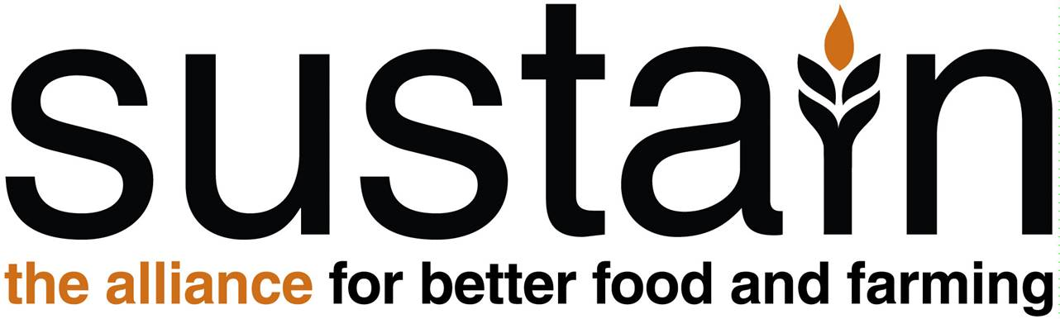
www.sustainweb.org

Election of members of the Council of Trustees of Sustain: The alliance for better food and farming

Sustain’s Council of Trustees are experienced and highly valued advisors on Sustain's governance and strategic direction. They are elected from and by Sustain's membership to form a governing body of up to 15 Trustees. In accordance with our memorandum and articles of association, a minimum of one third of the Council must stand down each year, and can either resign or stand for re-election. If you represent an organisation that is a member of the Sustain alliance, please consider standing for election at Sustain’s AGM (this will not be held as an event this year, we will conduct the business of the AGM wholly via email due to Covid-19 restrictions during November/December 2020).

What does being a Sustain Trustee entail?
Sustain’s Trustees attend four meetings per year, usually held on a Wednesday afternoon (currently via Zoom). We usually have one strategy day per year, which is for all staff and trustees to get to know each other and refresh our priorities. As members of the Sustain alliance, Trustees are often also involved in project and campaign activities in some way, so have direct experience of Sustain and how we work together. Some also serve as chairs of our expert working parties, supporting the project coordinators to help navigate project and campaign strategy and activities.

Improving diversity in Sustain’s leadership group
All of Sustain’s work is guided by values and principles of achieving a healthy, fair, humane and sustainable food system. Our alliance also has shared concerns that are highly relevant to the food system, but go beyond just food, farming and fishing, such as tackling climate change, restoring biodiversity, upholding human rights, and promoting economic prosperity and sustainable development that benefit everyone, not just a privileged few – at home and around the world. We want to actively promote diversity and inclusion across a wide range of characteristics. We are especially keen to use the trustee election process to improve the diversity – including racial diversity – of our Trustees. Please do consider applying – you will be most welcome.

Role shares to improve diversity
Additionally, to overcome barriers to participation for people from diverse backgrounds, we have opened up the option to offer some positions on the Council of Trustees as ‘role share’, meaning that a seat on Sustain’s Council of Trustees could potentially be shared between a senior representative of a Sustain member organisation (the ‘official nominee’ in the role-share) and someone perhaps with less or different experience, and from a background currently under-represented (the ‘supported nominee’), keen to gain experience of charity leadership and governance.

Each role-share will have one shared place and one shared vote. The ‘official nominee’ (usually the senior representative due to the alliance governance nature of Sustain) will be registered with the Charity Commission and Companies House as the Sustain Trustee with legal responsibilities, and will also – for legal reasons – have the authority to decide the joint position of the role-share in the event of any disagreement, especially on matters relating to the finances and good governance of Sustain as an alliance and registered charity. Note: This role-share opportunity is extended only for the purpose of improving involvement of people with ‘protected characteristics’ (including racial diversity) and less privileged socio-economic backgrounds, currently under-represented on Sustain’s Council of Trustees.

Deadline for submission of applications to be considered for election to Sustain’s Council of Trustees: 5pm, Friday 20th November, send to: Kath Dalmeny by email: kath@sustainweb.org
Sustain Trustee nomination form
To be considered for election to the Sustain Council of Trustees, return this form to Sustain chief executive Kath Dalmeny by 5pm on Friday 20th November, by email: kath@sustainweb.org. If you have any questions about the role, role-share or eligibility, please get in touch well before this date.

Name: Name of person nominated for election to membership of Sustain Council of Trustees
Organisation: Which Sustain member or observer organisation does this person represent? See the list here: https://www.sustainweb.org/membership/
Proposer*: What is the name and organisation of the person proposing your nomination?
Seconder*: What is the name and organisation of the person seconding your nomination?
* Note: Proposers and seconders should represent members or observers of the Sustain alliance. If you are not able to arrange a proposer and/or seconder in time for 20th November nomination deadline, please submit your form anyway and we may be able to help you. We are including a question in the election papers to ask Sustain members if they are happy to serve as proposers and seconders.
Role-share: Is this a nomination for a role-share to improve diversity? If so, please say who you propose sharing the role with. If both of you are new to Sustain’s Council of Trustees, please submit two nomination forms giving full details of each person, indicating which of you will be the ‘official nominee’ and which will be the ‘supported nominee’.
Improving diversity: Do you want Sustain to be aware of any ‘protected characteristic’ (including racial diversity and/or less privileged socio-economic background). If so, please provide any details you feel comfortable to share. Note: This information will be confidential to Sustain’s management team – we will use this only to track progress on improving diversity, and to inform conversation with you about how to make you feel welcome and able to participate. We will not declare this information in election papers, nor publicly except with your explicit consent.
Statement in support of nomination: Please provide c.200 that can be published in the election papers (and later – if you are elected – on Sustain’s website)
Declaration of interests: Please list any interests that would influence, or may appear to influence, your ability to make independent decisions in your role as trustee of Sustain as a registered charity.
Confirmation of eligibility: I confirm to the best of my knowledge that I am eligible to apply to be a charity trustee. I am not on the sex offenders register, I have no convictions for financial mismanagement or fraud, and I have no unspent convictions (or have an official waiver). Please answer Yes or No (provide further details if necessary).

