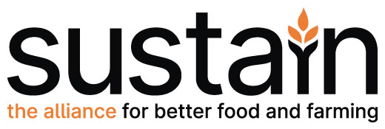

Sustain membership application form

Sustain is an alliance and membership is open to national public-interest organisations that do not distribute profits to private shareholders and whose governance ensures that the organisation operates solely in the public interest. Member organisations must be wholly or partly involved in sustainable food and/or farming issues and support the general aims and work of the alliance (www.sustainweb.org).

To apply for membership of Sustain: The alliance for better food and farming, talk to one of Sustain’s leadership team (contact details below), and/or return this form enclosing your latest annual report and accounts. Applications are considered by the Sustain Council of Trustees, which meets quarterly, and then at the next members’ meeting – usually the AGM.

Name and address of organisation
Purpose
Status (e.g. registered charity)
Structure, including governance arrangements
Activities
If an alliance or association of organisations, who are your members?
How are you funded? How do you manage any conflicts of interest to ensure that your organisation avoids commercial influence (particularly by the food and farming industries) and operates wholly in the public interest?
Sustain members can have one or more representative with one entitled to vote.
Voting representative (name, job title and email)
Second representative (name, job title and email)
Anyone else in your organisation who would like to receive our newsletter and information about events, publications and alliance activities? (name, job title and email)
Sustain alliance membership fee 2021-22. Please mark or highlight which membership rate you think applies to you. Add a note if there’s anything you want us to know about your membership application or subscription rate, or if you have a question.
Annual income (£) Annual subscription fee (£)
0 to 40,000 75
40,000 – 80,000 130
80,000 – 150,000 195
150,000 – 500,000 370
500,000 – 1,000,000 525
1,000,000 – 10,000,000 700
over 10,000,000 895
P
Membership or invoice enquiries: Abi Taylor, Finance Officer: abi@sustainweb.org

If you would like to discuss your application or ask any questions, please contact:
- Kath Dalmeny, Chief Executive of Sustain: kath@sustainweb.org
- Ben Reynolds, Deputy Chief Executive of Sustain: ben@sustainweb.org

Whether or not you become a Sustain alliance member, please do consider joining us for our
meetings and events, and for our Annual Gathering, which usually features a topical talk and
lively debate. Your organisation may also be interested in joining one of Sustain’s advisory working parties, supporting our alliance’s campaigns and projects, and signing up to one or more of our newsletters. Details are at: www.sustainweb.org/get-involved/

Sustain: The alliance for better food and farming, 244-254 Cambridge Heath Road, London E2 9DA. Tel: 020 3559 6777; www.sustainweb.org. Sustain is a UK charity, number 1018643.

Sustain membership application form updated August 2021

