No Loaf Lost pledge | 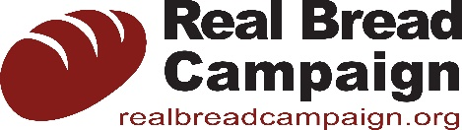

No Loaf Lost is a Real Bread Campaign initiative to encourage and help small, independent bakeries to reduce the number of surplus loaves they produce.

Signing the No Loaf Lost pledge is our promise to take appropriate steps to minimise our surplus and waste and to promote this important work to customers and others.

Specifically we pledge to do the following:

- Publically state our commitment, promoting this to customers and more widely
- Appoint a champion responsible for loaf surplus and waste reduction
- Measure the weight and retail value of loaf surplus and waste we produce for two weeks
- Write and implement an action plan with targets to reduce our loaf surplus and waste
- Aim to redistribute or repurpose 100% of any surplus that remains
- Train staff according to our plan
- Report results to the Real Bread Campaign every six months, reviewing and (if necessary) revising our plan
- Help to influence wider progress in loaf surplus reduction by other bakeries

Signature

Name

Company

Job title

Date

What significant step(s) will you take to fulfil this pledge?

Estimated number of loaves baked per year

