Food as a priority for your Climate and Nature Action Plan

The climate and nature emergency and food
In the UK, 30% of greenhouse gas emissions arise from the food system and food related land use change. Additionally, a third of the food we produce goes to waste. Intensive farming and fishing practices are the main drivers of biodiversity loss. Fixing the food, farming and fishing system is therefore one of the essential and large-scale ways to help avert climate change and restore nature. Indeed, it is critically important that we tackle food consumption to have any hope of securing our future supply of food.
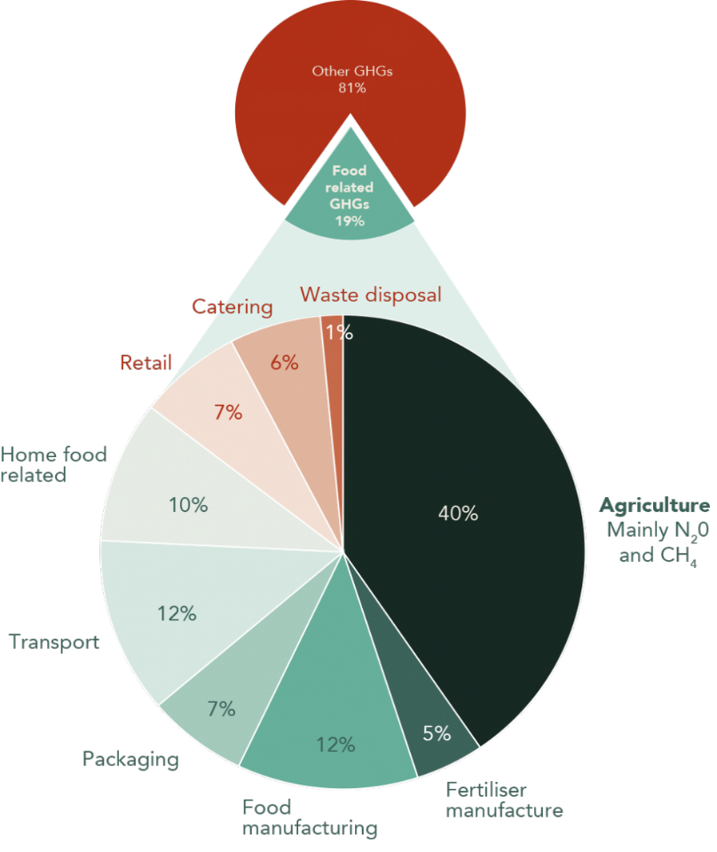
Food is probably our biggest consumption-based emitter
Other GHGs

Food related GHGs
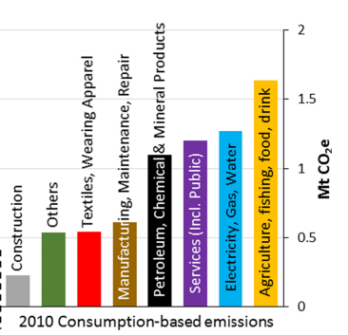

Contribution of the food system to UK emissions (excluding land use change). Source: FCRN, 2015. | Consumption-based GHG emissions for Bristol in 2010 Source: Millward-Hopkins, 2017

Actions to add to your Climate and Nature Action Plan, to help see quick wins for GHG reduction, benefit nature and improve citizens’ health.

- Substantially increase the market for healthy, sustainably produced food
- A sustainable food policy for all council-controlled procurement, including serving 50% less and 100% better meat (See our ‘What is ‘Better’ meat and dairy’ note on page 2). You should also serve more fruit and vegetables, sustainable fish, buy a certain percentage of local and seasonal food, and Fairtrade for at least tea, coffee and bananas. The policy should tackle heavily processed food like fizzy drinks to reduce the big food-footprint related to sugar and food processing. The policy should apply to council-controlled schools, libraries, older peoples’ services and other catering purchased with council funds.

Source: BBC News, quoting Poore and Nemecek, 2018

Halving the meat served in schools would save an estimated 195kg CO2 per pupil, per year.
- Make Council meetings and events meat-free. In doing so the council will lead by example and incentivise suppliers to cater in this way.
- Adopt flexible menus and recipes to make good use of produce that is not cosmetically perfect; less favoured cuts of meat and using the whole carcass; underutilised fish species (relieving pressure on the handful of over-popular species); as well as seasonal gluts of fresh produce.
- Commit to being a fair food buyer, paying on time and not changing prices or orders at the last minute – practices known to cause food waste on farms and in manufacturing.
- Provide places and ways for farmers to sell directly to businesses and consumers, helping them retain more of the value of the food they produce.

- Use your planning and licensing power
- Protect community food growing and market spaces, and make these a requirement in new building developments.
- Implement supportive business rates and other licensing conditions for businesses that are helping tackle the climate and nature emergency, for example serving less but better meat, and/or wasting less food, and eliminating single-use plastic.

- Install drinking water fountains
Freely available drinking water can help people to cut back on single-use plastic, waste and consumption of sugary soft drinks. From September 2019, City to Sea and Sustain are asking local areas to:
- Publicly commit to the target of 50 working public fountains.
- Map their existing drinking fountains on the Refill app.

- Use land well for climate and nature
- Protect high quality Grade 1 farm land for food growing, and require land tenants to demonstrate how they are maintaining and enhancing the high grade of their land and soils.
- Make peri-urban land and county farms available for agro-ecological farming and new-entrant farmers.
- Make agro-ecological farming methods a requirement of any Council contract or lease, including Whole Farm regenerative approaches.

- Other actions
- Reduce the amount of food waste sent to landfill by businesses and residents.
- Require all recipients of Council grants and funding to implement a sustainable catering policy.
- Restrict food delivery (i.e. takeaways and supermarket deliveries) that are not carbon neutral (allow renewable-powered electric vehicles and cycle deliveries).

- Measure what matters
To ensure progress, measure at least the following:
- The volume and/or value of sustainable food bought. You may include also pasture-fed, LEAF-Marque or organic certified, Fairtrade, organic, sustainable fish.
- The amount of meat served in council-controlled settings.
- The amount of surplus food and food waste reduced or diverted to good uses, explicitly in line with the Food Waste Hierarchy.
- The number and diversity of farms, and hectares under agro-ecological production.
- Coastal Areas - The number and diversity of fisheries under verifiably sustainable management.
What is ‘Better’ meat and dairy?
Animals raised in more humane conditions are less resource intensive, use fewer antibiotics, have been found to be better nutritionally and lower in saturated fat. Using land as grazing pasture can be beneficial to soils and wildlife.
Currently, there is no label that delivers across all better meat and dairy principles, although organic comes closest and is the best choice for all items. These are good alternatives:
LAMB AND BEEF – Pasture fed, LEAF-Marque PORK – Free range, LEAF-Marque
CHICKEN/TURKEY/DUCK – Free range or RSPCA ‘enriched’ indoor reared is also OK
EGGS – Free-range is good, cage-free is a minimum MILK – Pasture-fed is good

Core facts and where to find more information
- Meeting the Paris Agreement (2015) targets requires a significant reduction the amount of meat and dairy that we consume and a shift towards a plant-rich diet.
- All meat has a relatively high carbon footprint but how animals are reared significant affects their environmental impact. Intensive ‘factory’ farming is harmful for animal health and welfare and requires large volumes of grain and soy for feed. Animal feed is a key cause of global deforestation with an estimated 93% of soy grown globally fed to animals.
- Diets rich in red meat and, in particular, processed meats have been linked to higher incidence of coronary heart disease, stroke, type II diabetes and cancers.
- A study from Oxford University found that reducing average meat consumption in the UK to two or three servings a week could prevent 45,000 premature deaths a year and save the NHS £1.2 billion .

This is an extract from the report ‘Every Mouthful Counts’ a report released by Sustain in September 2020. It is focussed on cities, and includes more information about how changes in our food system can help tackle the climate and nature emergency at the same time as improve our overall health.

For more information, please contact Ruth Westcott, Climate and Nature Emergency Co-ordinator at
Sustain: The alliance for better food and farming
ruth@sustainweb.org

The Green House, 244-254 Cambridge Heath Road, London E2 9DA.
020 3559 6777

Sustain advocates food and agriculture policies and practices that enhance the health and welfare of people and animals, improve the working and living environment, promote equity and enrich society and culture.
We represent around 100 national public interest organisations working at international, national, regional and local level.
Registered Charity No 1018643

Briefing by Ruth Westcott and Leyre Iñiguez de Onzoño Sanz

FCRN (The Food Climate Research Network, 2020) estimations including the food chain and food related land use change, including deforestation.
Tristram Stuart (2009) Waste: Uncovering the global food scandal. Penguin Books
State of Nature Partnership (2019) State of Nature 2019 https://nbn.org.uk/wp-content/uploads/2019/09/State-of-Nature-2019-UK-full-report.pdf
Data on CO2 emissions from different diets here: https://link.springer.com/article/10.1007/s10584-014-1169-1
Data from the Eating Better Alliance (2018) - Principles for eating meat and dairy more sustainably: the ‘less and better’ approach
Scarborough et al (2010) Modelling the health impacts of the diets described in ‘Eating the Planet’ published by Friends of the Earth and Compassion in World Farming. University of Oxford.

