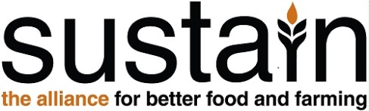

Cage-Free Pledge

London is a modern, thriving city where there is no place for food produced under outdated cruel methods. Sustain is asking all London Boroughs, high profile institutions, landmarks and tourist attractions to publically commit to using only cage-free eggs and egg products in 2015. In doing so, you are directly helping to improve the quality of life for laying hens, as well as making cages a thing of the past.

Details

Borough / Institution ……………………………………..…………………………………………….

Contact name ……………………………………………..………………………………..………….

Position …………………………………………………………..…………………..…………………

Address …………………………………………………………..………………..…………………...

Telephone ………………………………………………………..…………………………..…………

Email ……………………………………………………………..…………………………..…………

Pledge to use only cage-free eggs

Please confirm you only source eggs (shell eggs and egg products) from hens free of cages or will do so before the end of the fiscal year 2015/16:

Yes ( )

Please add information that you would like to share with us, especially the reasons why you decided to sign this pledge. E.g. Why have you chosen cage-free eggs or your current cage-free supplier? Is your choice for cage-free eggs motivated by your customers, or the quality of the eggs?

………………………………………………………………………………………..………………….

………………………………………………………………………………………..………………….

………………………………………………………………………………………..………………….

………………………………………………………………………………………..………………….

………………………………………………………………………………………..………………….
Signature of Board level Director

By signing this pledge

- You are confirming that 100% of the eggs you use – or will use by the end of the fiscal year 2015/16 – are cage-free.

- You are agreeing that Sustain may be in touch to monitor your pledge. Otherwise you may consider applying for a Compassion in World Farming Good Egg Award if you wish to make the cage-free commitment a permanent one.

Signature ……………………………………………………………………………..…………

Name ………………………………………….… Title …………………………………………

Date ……………………………………………… Email ………………………………………

Please return to

Sofia Parente
London Food Link
Sustain: the alliance for better food and farming
Development House, 56 - 64 Leonard Street, London EC2A 4LT
0207 065 0902 | sofia@sustainweb.org | www.sustainweb.org

