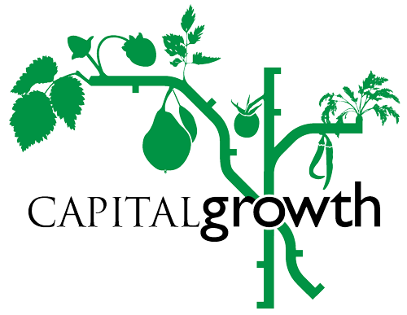
Press Release

London’s edible gardens get ready to share their urban harvest

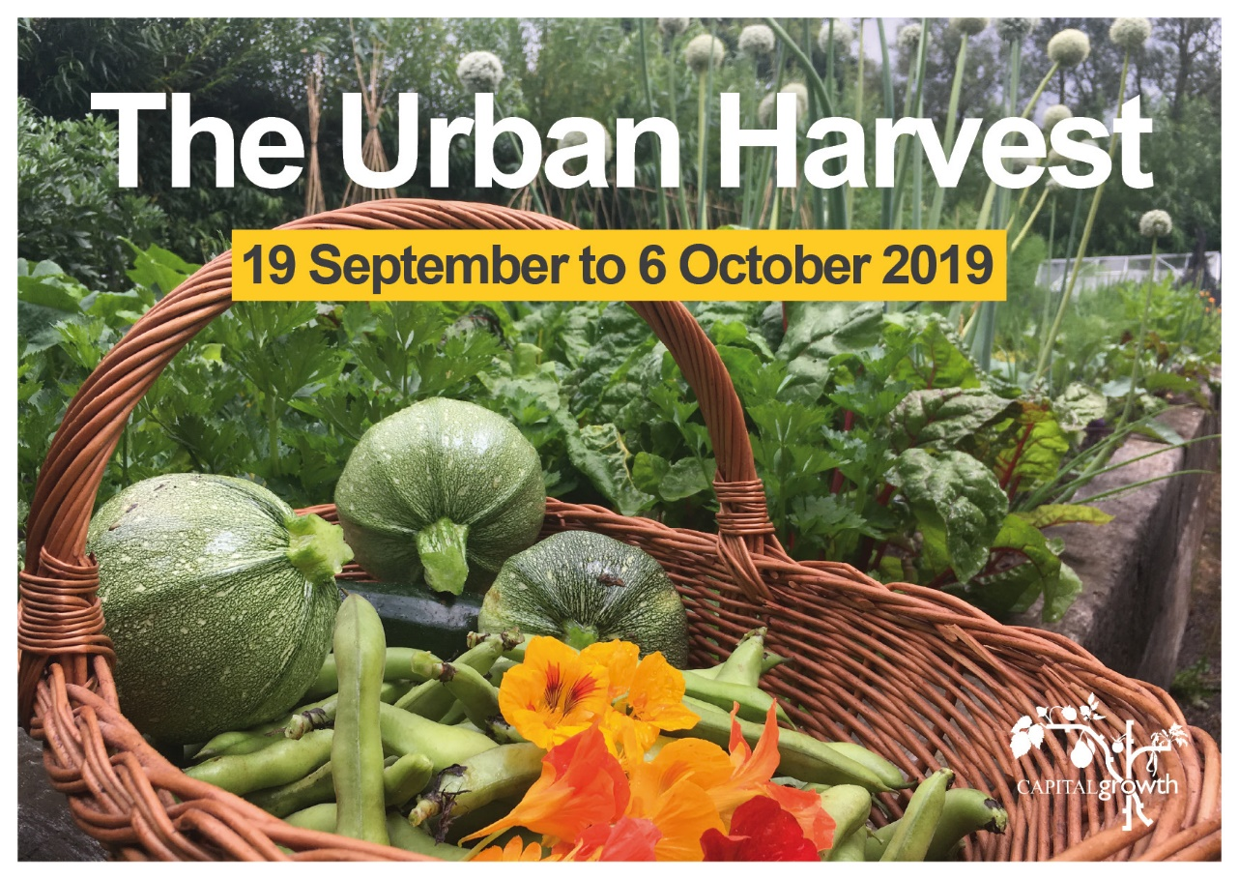
28 August 2019

From mushroom-growing to urban-beekeeping, Londoners will get a chance to learn about and taste fresh, delicious food grown in the city as part of The Urban Harvest event, running from Thursday 19 September to Sunday 6 October.
The city wide event will include harvest feasts, hands-on workshops, tours and family friendly activities to celebrate London’s edible gardens and enjoy the city's harvest.
Gardens taking part in The Urban Harvest include
- Maryon Park Community Garden in Greenwich (21 Sept) offering garden tours, talks as well as having woodcraft and garden produce goodies for sale.
- Rainbow Grow in Hackney (28 Sept) will host a Fungi themed event with lots of mushroom-related activities, including an urban mushroom growing session and a specially catered mushroom-focussed buffet. In Hackney you can also visit Growing Communities market garden in Clissold Park (22 Sept), meet the growers, have a garden tour and get growing tips
- Christ Church C of E Primary School (21 Sept) in Greenwich will have activities in their Forest School woodlands, a talk with their urban beekeeper.
- MindFood in Ealing will be running a garden mindfulness session (21 Sept), and celebrating Apple Day (28 Sept).
- Hackney Herbal (21 Sept) will be their new home in Hackney Wick, celebrating the autumn equinox with nature-based craft, herbal drinks and teas made by the harvest of urban herb growers.

The annual autumnal city-wide garden event is organised by London food grower’s network, Capital Growth, to celebrate community gardens and give people a chance to visit and see just how much food is grown in urban areas. People can check out the online map of gardens taking part.
“Pumpkins are getting heavier, tomatoes are ripening and peas can still be eaten fresh from the pod – September is the season of abundant harvest and a perfect time to discover what’s growing in the city” says Janelle Conn, from the Capital Growth team. It’s a great way to explore London’s hidden gardens and learn about all the amazing ways to grow food in urban areas.” Capital Growth’s flagship allotment garden in The Regent’s Park, run with the Royal Parks, will host their annual harvest party, where visitors can have a go at pressing fresh apple juice, take part in garden competitions or grab a pizza fresh from the cob oven topped with garden produce. There will also be children’s activities, live music and plenty of garden goodies for sale to benefit the project’s ongoing work with local schools.
A full list of participating gardens, the dates of their Urban Harvest event and their activities can be found on our Urban Harvest map.
The Urban Harvest is a flagship event taking place during London Food Link’s Urban Food Fortnight which celebrates the people who grow, make, cook and save food in the city. This includes is the 21st London Harvest Festival (28 Sept) will include a horticultural display, farm craft activities from spinning to pottery to metalwork in the forge, animal shows with goats, cows, sheep, chickens, and more, and even a local goat's milk ice cream truck. Other activities include supper clubs in gardens, growing workshops and special menus at restaurants using urban grown produce.
For full details about The Urban Harvest, please visit www.capitalgrowth.org/events/opengardens
ENDS
For more information or photos contact Janelle Conn at janelle@sustainweb.org or 020 3559 6777 or visit
www.capitalgrowth.org
@Capital_Growth
facebook.com/capitalgrowth
Editorial Notes
- Capital Growth is a London Food Link project (part of the charity Sustain), started in 2008 to help set up 2,012 new community food growing spaces by the end of 2012. Capital Growth continues to support over 2500 members to set up and run gardens, with funding from The Mayor of London, National Lottery Heritage Fund, Centre for Ageing Better and Ernest Cook Trust.
- The Urban Harvest is a showcase event taking place during London Food Link’s Urban Food Fortnight, which celebrates the ultra-local food being grown, cooked, made and saved on London’s doorstep and runs from 19 September – 6 October. Check out the full listing.

