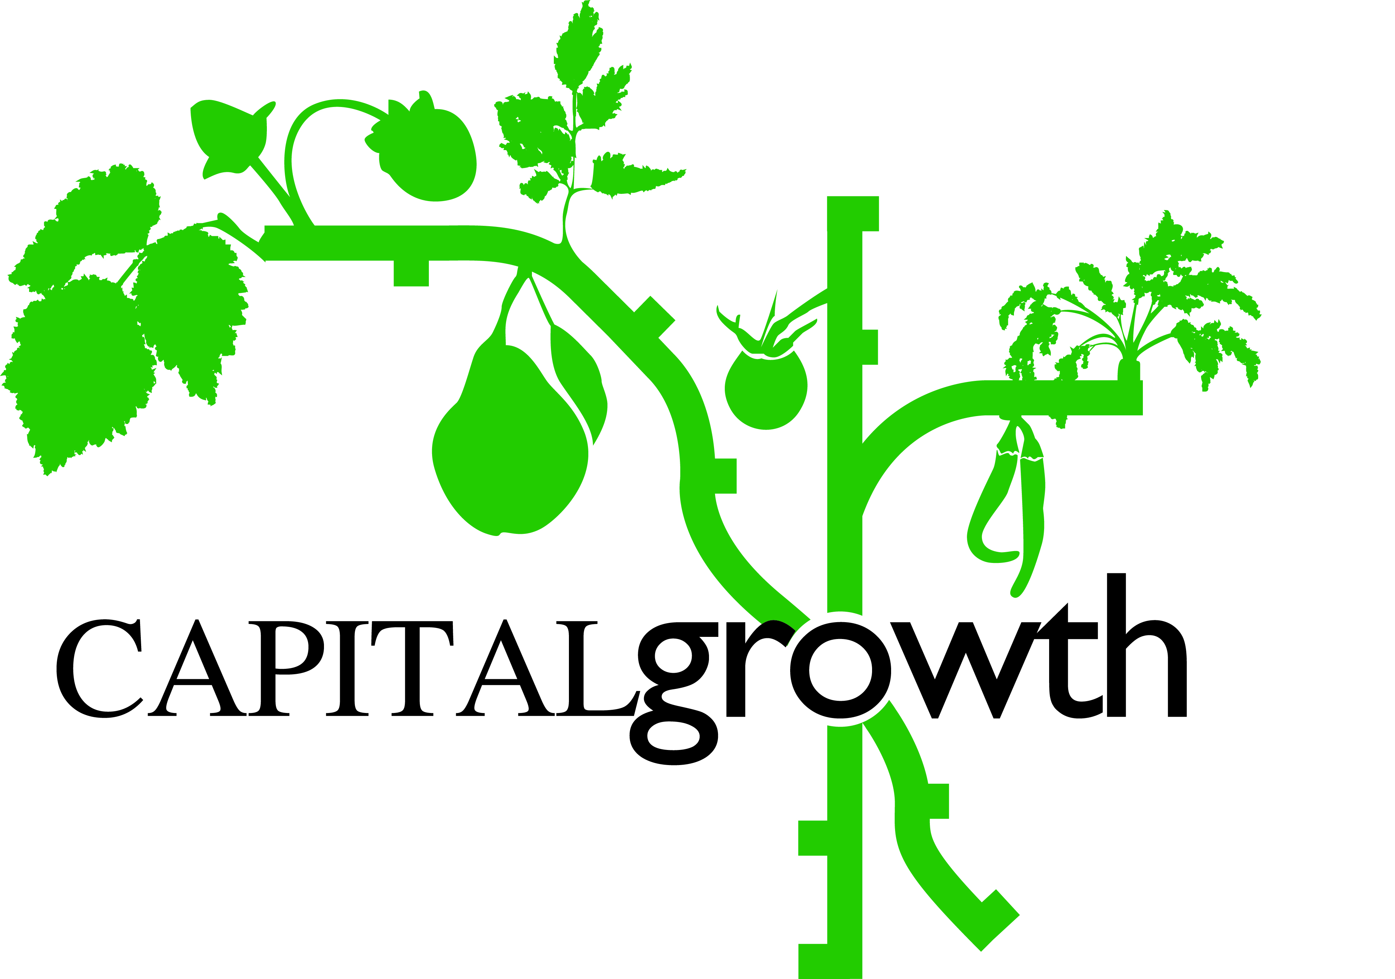
Photo Permission Form
The Urban Harvest 2019

Project Name……………………………………………………..

I, (name)……………………………………………………………………………………………………………………………

of (address)……………………………………………………………………………………………………………………….

……………………………………………………………………………………………………………………………………………….

am over 16 years of age and agree that the photographs/film of me and/or my child(ren) in my care:

(names, optional)……………………………………………………………………………………………………………………

may be used for promotional purposes, as listed below, by

(name of space)…………………………………………………………………………………………....

and Capital Growth and The Urban Harvest project at any time during the next ten years:

- In literature/printed materials
- In the media
- On the Capital Growth website
- On other websites displaying The Urban Harvest information
- On other promotional materials related to The Urban Harvest or Capital Growth

Signed…………………………………………………………………………………………………………………………………….

Print name………………………………………………………………………………………………………………………………

Date………………………………………………………………………………………………………………………………………..

Email……………………………………………………………………………………………………………………………………….

Thank you for agreeing to let us use our images of you. Whenever possible we will contact you to let you know about any publication of the images.

