Capital Growth
Training Hub/Partner Application 2020
Please read this form carefully, complete and email to janelle@sustainweb.org by Wednesday 8 January 2020 at 12pm.
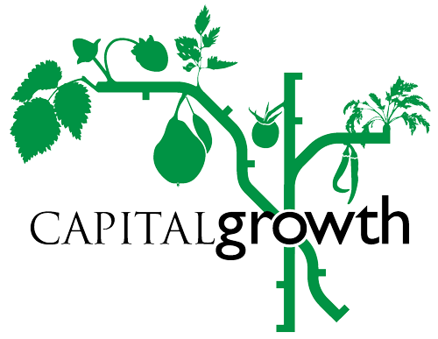

c/o Sustain: The alliance for better food and farming
The Green House, 244-254 Cambridge Heath Road,
London E2 9DA
Registered charity no: 1018643

Capital Growth was established in 2008 and a key part of our support for gardens and supporters has been our training programme. We have been working with Training Hubs since 2016 to co-host training and in 2018 we added a new role for Training Partners to pilot training at their site.

Together, with our hosts (Hubs/Partners) and trainers we delivered 39 courses to 484 participants in 2019. With your support we would like to continue to grow the programme in 2020 and reach even more people across London.

Capital Growth will support Training Hubs/Partners to schedule, promote and host training course and open days. In 2020 we will have 6 training themes, see https://www.capitalgrowth.org/training_hubs_partners for more information.
- Climate resilience: Sustainability and growing for the future
- Grow for nature: Improving biodiversity, habitat creation and growing organically
- Growing connections: Growing for health, wellbeing and community
- Growing culture: Focus on London's food growing heritage
- Growing enterprise: Focus on enterprising ideas and selling produce
- Get children growing: Engage children and young people outdoors
*Note: We welcome applications from previous Hubs/Partners, but we will favour new suitable applicants when possible to give new gardens a chance to participate.

What is expected from a Hub/Partner?
- Capacity to host a training session with 20+ participants. Ideally there would be an indoor/covered area with electricity for Powerpoint etc. but this is not essential for all courses.
- Host a minimum of 2 (per Hub) or 1 (per Partner) training sessions. Gardens can suggest training they would propose to deliver, and we can match gardens with trainers experienced in the areas of learning needed/required. Note: we are also recruiting trainers.
- Take part in 2 Capital Growth London wide open days (The Big Dig on Saturday 25 April 2020 and promote an Urban Harvest event through Capital Growth on a date that suits your project in September).
- Help promote all training and open days through networks, social media and other methods.
- Provide a primary contact person for liaising with Capital Growth.
- Support with promoting and marketing training and events to your stakeholders and in the local area.
What will Capital Growth offer?
- Pay the host to deliver the training directly or pay a Capital Growth approved trainer were agreed. We pay £40/hour plus a £30 admin fee (to cover printing feedback sheets and any handouts, postage and refreshments) and our courses usually run for between 2 and 3 hours. We are also open to suggestions for full day courses of up to 6 hours. e.g. for a 3 hour course the fee would be £150 (inclusive of VAT)
- Cover the costs of materials, but only where agreed in advance as this may affect how we price the course.
- Help with planning/reviewing training sessions and matching host with approved trainers
- Management of ticket sales and bookings (via Eventbrite)
- 3 complimentary places for garden volunteers/staff on each course hosted by a Hub/Partner
- 5 complimentary places for Hub/Partner garden volunteers/staff on any short course Capital Growth training throughout 2020
- Help with publicity for training and events including our training calendar that will feature all Hubs and mention Partners, our newsletter and social media.
- Promotional material and support to run open days

General information
Primary Contact Name:
Site Name:
Capital Growth Space Number:
Site Address:
Site Borough:
Email:
Phone number:
Have you been a Capital Growth Training Hub or Partner before*?
Website:
Facebook/Twitter/Instagram handles:

Applicant questionnaire
Please fill out the following questions in no more than 150 words each.

- Tell us a bit about your growing project: How long has it been running? Do you grow mainly food? What kind of organisational body runs it? (e.g. volunteers, staff, board etc.) Who owns the land? Are you based in a park, allotment, housing estates etc?

- Tell us a bit about how the community is involved in the project: Do you have regular volunteers? Do you meet weekly? How many people are involved? Are you a school or other type of community group?

- Why would you like to be a Training Hub/Partner?

- What training would you propose to deliver directly for Capital Growth and which of our 6 themes would this best fit within? Do you have expertise in a specific area that you could share? Have you delivered this training before and have you any feedback to share? (Our standard courses are 2.5/3 hours, but we are also interested in proposals for full day/6 hour workshops)

- What type of training would you like to host/your members like to join from an external trainer? (e.g. bring in a Capital Growth trainer to teach garden participants about heritage varieties, seed saving or medicinal herbs) Is this a specific need you have identified you’re your group, members, volunteers?

- Have you hosted open days in your garden? Have you hosted a Big Dig or Urban Harvest event before with Capital Growth? If yes, tell us a bit about them including what activities were offered and approximately how many people came. If no, what sort of activites would you offer if you were to hold an open day?

- How would you promote training/open days in your garden as a Training Hub/Partner, e.g. training and open days?

About the garden site

- Are there any unique features to your site? (e.g. pond, wildlife area, cob oven, bee hives etc.)

- What is your maximum capacity to host people on a training course a) inside and b) outside? Please give exact numbers for both.

- Any other comments?

