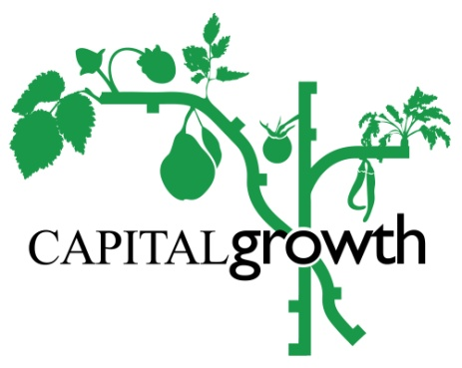
Growing Schools Marketplace
Friday 12 July 2019 Application Form
Please return the completed form to janelle@sustainweb.org by Friday 5th July 2019.
Contact Details
Your name
School’s name
Capital Growth space number
Email
Phone number

What types of produce/products do you think will you bring to the school marketplace and in what quantities? This could be anything from fresh produce, like tomatoes, herb bunches or potatoes, to school-made goods, like jam, chutney, cordial, potted plants, seeds, baked goods, hanging baskets or fresh snacks. Everything should include produce from your school garden.

How many people will be coming from your school? We allow a maximum of 5 people to come, including children and adults (pupils must be able to attend to take part in the day). Please specify the number of children and adults.

Are you interested in being involved in our new Growing Culture project? We would like reach out to primary schools and deliver workshops to grow heritage variety crops and to explore and share London’s food growing history through research and oral history interviews with older growers. Do you have any ideas how your school could be involved, or how this could relate to the School Marketplace?
Yes/No
What are your ideas?
Please note
- Each school will be provided with and allocated ONE table (1x2 meters), so please only bring enough produce to fit this space and ensure you can carry it from transportation to City Hall as necessary. Table dressing (table cloths, labels and any other decoration) will be the responsibility of the school.
- Parking at City Hall is difficult so we ask that use you public transport, disabled parking is no longer available below City Hall.
- There will be three competitions throughout the day with prizes for Best Dressed Stall, Most Innovative Product and People’s Choice.
If you have any questions please email janelle@sustainweb.org or give us a ring to the office at 020 3559 6777. Thanks for taking part and we’re looking forward to a great day!

