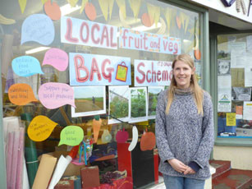
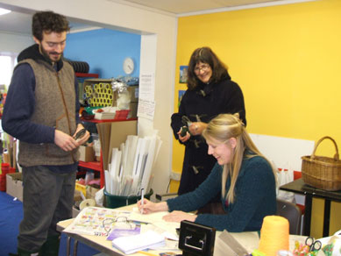

Summary
Windmill Hill Organic Project (WHOP) in Glastonbury in Somerset is a small, informal pre-packed bag scheme, based on a residential estate on the outskirts of a rural town. They supply organic fruit, vegetables bags and potatoes to local residents. The project is hosted at a community Scrapstore.

Background
A Somerset Community Food Fieldworker initiated this project in 2004, as one of the targets of their role. The aim was to improve access to affordable healthy, organic food. The expected outcomes were to supply twelve or more local families with produce and provide other activities to support the project, such as cooking classes. Food access is a key issue as the estate is a strenuous walk up a hill from the town centre and there is only one local convenience store; that did not sell organic or local food. A short questionnaire to assess need was circulated to neighbours and friends prior to a meeting in the local community hall. It was established and agreed that the group would provide organic fruit and vegetables weekly at this hall. Volunteers signed up to help once a month to receive delivery, distribute and take orders. A supplier was sourced through local contacts; he was a newly established grower who supplemented his produce from the regional wholesale market. This arrangement lasted for over a year until the grower withdrew from the scheme due to feeling overstretched.

Developments
The fieldworker moved on and the project was taken on by a by a local volunteer. A new supplier was found following research into alternatives; the group chose a larger, more experienced farmers co-operative. The project moved around the corner to the community Scrapstore.

People involved
The fieldworker was key in the start-up and Somerset Community Food workers offered advice and support in obtaining grants. The organic producers co-op offered advice and support at a later stage, alongside GEMS Scrapstore workers, willing to integrate and support the project.

Resources
The group received a small start-up grant from Somerset Community Food and this enabled the purchase of a printer, ink and paper for producing posters and flyers. Funding was gained from the local housing association for the initial year at the new venue and the group is still looking for small grant funding to contribute towards rent and phone calls. The Scrapstore has agreed to house the project in the longer term and has a visible shop front, which benefits the project in terms of publicity. There is a small mark-up on some produce to contribute towards running costs; mostly phone calls.

Promotion
This work has focussed on regular coverage in the local press and joining in with community food events e.g. harvest show. Reminders have also been sent to community on-line groups. The group have recently displayed a large hand-painted banner in the window, which has led to four new enquiries and two new regular members.

Achievements
Success is based on generating enough orders each week to continue. The weekly order varies from 8-16 customers, with summer being the quietest time. The project has run with a small group of core members with a larger number ‘dipping in’. 45 individuals and families used the project over the last year. Members share recipes and advice with each other from time to time, very often trying to help others with less popular vegetables. Positive feedback from customers often comes in the form of how they are eating more fresh produce and gaining confidence in cooking with seasonal foods. Community members talk about feeling part of the project and develop a sense of loyalty to local producers.

Future
This project ticks over most of the time with the occasional need to do some promotional work. They plan to do a window display in the New Year which will promote the project and highlight some positive cost comparisons of buying produce through the scheme.

