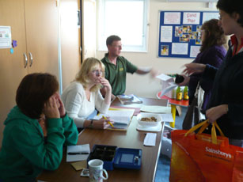
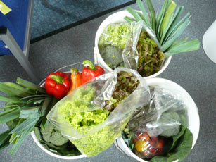

Summary
Two food co-ops run in Wellington in Somerset, one during the afternoon on Tuesdays at Wellington Children’s Centre (since July 2007) and the other at The Young People’s centre on Monday evenings (since June 2008). They supply some pre-ordered fruit and vegetables weekly, alongside fish and meat packs at intervals, eggs and fruit juice are also sold. All this produce is sourced from the surrounding area.

Background
The food co-ops have developed from initial work by a Local Authority funded Food Access worker and are now run by passionate and committed volunteers. The first project at Rockwell Green has now closed and this has transferred to the Young People’s centre – due to lack of volunteers and declining customers, the project needed a fresh start. The food co-ops initially received a small grant from the town council to help with start-up costs. The food co-ops are growing steadily. The food co-op has their own bank account and takes Healthy Start vouchers towards payment

Volunteers
Two key volunteers manage and run the project and motivations are based on access to healthy and sustainable food for the local community. Marina, one of the volunteers said ‘I believe in the project and want to get as many people as possible involved, whilst improving my own knowledge and confidence’.

Training
Both volunteers have participated in the Somerset Community Food ‘Know your Onions’ training. Key motivation to take part was to help underpin motivation and prevent feeling overwhelmed as the food co-ops grow. Organising and promoting skills developed on the course are contributing to the food co-op’s progress.

Producers
Wellington is exemplarily at sourcing very local produce from a range of suppliers. They have an added advantage as the vegetable grower, Ray Weymouth, spends time at the food co-op talking with customers, developing a strong customer to farmer link. Due to the regular purchase of his crop, Ray has taken on an extra field to grow more vegetables. Soft fruit is also on offer when in season - when we visited the food co-op we were fortunate enough to buy the last, end-of-season raspberries and strawberries, which are supplied by a local fruit farm and delivered jointly with the vegetables. Apple juice and eggs are ordered in bulk then sold on. £15 and £30 meat packs are sold from Beech Hayes Farm

Members
The food co-ops attract a mixture of local people. Whilst the food co-ops continue to gain new members there are many people who have kept ordering their produce. This is clearly because they think the produce is fantastic and very good value! Some members value the choice they have in stating up to three items they do not wish to have in the vegetable bucket.

Informing/educating members
The food co-op has a recipe folder for members to find out how to prepare and cook more unusual vegetables and people bring their own recipes to add to it. Direct contact with the farmer also develops understanding of food growing and seasonality. Although not organically produced the food co-op chooses suppliers who take a sustainable approach and use natural growing methods – this is highlighted to members.

Promotion
Wellington has established itself as a food town – so the food co-op promotes itself at the annual food festival. They have also produced and distributed fliers. They are just testing out a banner to raise awareness of their project.

The project has also hosted visits from other people interested in setting up food co-ops in the local area; they are keen to share their knowledge and experience. They also enjoy finding out about projects further afield and are off to visit a community shop project in the near future.

Future
The volunteers are keen to expand their range and are researching the supply of local bread. They are in the process of setting up a fish cooking demonstration at one of the local cafés. They also hope to get more families to use the food co-ops as well as generally recruiting more members.

