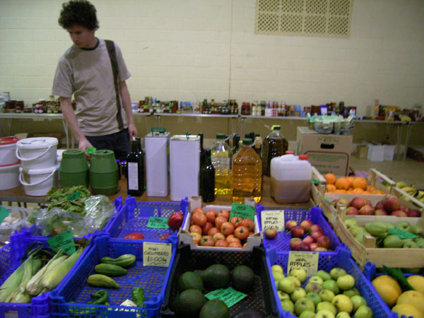
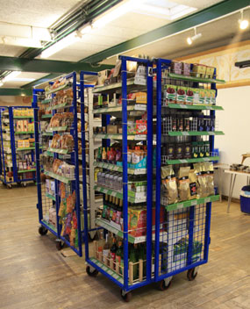
Summary
True Food Co-op in Reading is a community owned enterprise with 130 members. The company employs four part time staff and holds a wide range of stock from several wholefood wholesalers including Infinity Foods and Suma. They also source local fresh products and run weekly ‘markets’ in several locations.

History
The True Food Co-op was formed in 2005, initially as an informal buying club with 10 -20 members, and has grown steadily to 130 members by 2008. True Food has received several grants which has been vital for growth of the enterprise. “We would not have got the ball rolling otherwise” says founding member Chris Aldridge. Support has been received from:
- Berkshire Community Foundation
- European Social Fund
- Social Enterprise Berkshire – for marketing
- Primary Care Trust – for a cookbook

Governance
Members of the co-op are from mixed backgrounds. There are no restrictions to membership, other than to purchase a £1 share, although the enterprise is considering some obligatory participation. The co-op looks to attract people that want to try out new ideas for obtaining and promoting:
- affordable organic foods
- co-operative principles and volunteering
- sustainability in the environment
- community building and networking

How are decisions made?
There are 3 levels of decision making:
- Key workers - (part time employees) attend to the day to day running of the enterprise. These are a markets manager, warehouse manager and two markets assistants.
- Management committee – this includes 4-8 elected members plus 2-3 co-opted individuals with expertise to offer. They attend to policies and processes - development and management.
- Membership – Larger issues are taken to the membership and discussed at regular member meetings (used to be quarterly, possibly reducing to 3 times a year). Meetings are open, formally advertised in advance with opportunity to put forward resolutions for debate. Meetings are chaired and minuted.

Legal form
True Food is incorporated as an Industrial and Provident Society (IPS) – Society for The Benefit of the Community. This option was chosen on the advice of Co-operatives^{UK} as it is community oriented and cannot profit individuals. There has been some discussion around ways to encourage active participation. One possibility would be to pay a dividend to active members and in this instance the rules would need to be changed.

On joining, members sign up to the objects of the organisation, which are written into the ‘rules’ – see http://www.truefood.coop/constitution - and on the application form. The enterprise also has written policies for:
- Employment
- Environment
- Health and safety

Finance
As well as four part time staff, the enterprise rents a warehouse with an office and runs vehicles which contribute significantly to the businesses fixed costs.

Revenue is generated through a mark up of all products sold through the food co-op. Average mark up is 30% which compares with an independent retailer, which may charge at 33 -35%. Margins vary from product to product:
- Loose items: 33% (allows for some losses through spillage, etc.)
- Pre-packed groceries: 25%
- Few fast selling items e.g. soya milk: 20%
- Vegetables: 35% (these are labour intensive and when ordering stock, an allowance is made for 10% wastage)
Members making bulk orders in advance can get a 5% discount.

Members currently do not make any annual subscriptions, and administration of membership is covered through income, however this is a fairly significant cost and in future a reasonable membership fee may be introduced.

Activities
Although the enterprise is owned by 130 members, the markets are open to the public and they serve up to 2000 people per month. This is estimated to be approximately 600-800 customers.

The enterprise sources thousands of products from a range of suppliers; Suma, Infinity foods, amd local suppliers – including local charities such as Thrive who work with people with learning and physical disability through horticultural projects.

Produce is predominantly certified organic, although production practices for local produce is based on trust. They supply some uncertified ‘organic’ produce from growers that do not use chemicals and members’ contributions from allotments and gardens. The markets provide for most consumer needs: vegetables, fruit, meat (Graig Farm), dairy, bread, a wide range of wholefoods, beverages (mainly non alcoholic), non-food products such as cleaning and body care products and other items such as recycled paper, cards, and bin liners. Goods are delivered weekly from suppliers to the True Food depot. True Food then distributes to a number of trade accounts – restaurants and cafes, and eight ‘markets’ at community venues – five weekly, two periodically.

Members can reserve some items, but generally not entire orders. Most shopping is done from stock items. Only meat is paid for in advance, all other items are paid for on collection. Orders made by phone and e-mail.

Finding suitable venues for the markets is often difficult. Local authority venues are expensive so they try to use community centres, church halls and schools, but these tend to be more difficult to use due to times available. Rural venues are also difficult to run as populations are dispersed which in turn also makes it difficult to promote and do marketing. True Food has deliberately chosen venues away from established wholefood shops, however many have closed in Reading and the need has been met by True Food.

True Food employs four part time workers: a markets manager, warehouse manager, two markets assistants who attend to the day to day running of the enterprise. However there is a great deal of volunteering which is actively encouraged and managed. It is estimated that 60% of members are active and about 40% inactive.

There are several working groups:
- Finance – grant applications, etc.
- Policies
- People – human resources, volunteers, events and socials.
- Publicity – marketing.

For active members, there is a small discount on shopping – entitlement is monitored by the market managers and volunteer co-ordinator. There is also a Christmas party and summer picnic for volunteers. For any new start food co-op, True Food recommends that an expectation of volunteering and contribution to the food co-op is maintained from the onset in order to keep costs down and build social networks and benefits.

Members are kept informed through:
- E-mailed newsletter
- Website
- Meetings
- markets

The Future
True Food has identified several objectives to ensure its successful development into the future:
- May introduce an annual subscription fee to cover the costs of administration.
- Increase participation of members and other people. They are discussing how to provide incentives and ideas include the possibility for volunteers to accumulate credits – this would require a constitutional change. It may also be made an obligation to contribute a certain amount of work time to the food co-op.
- Move into a larger premises and open a shop.
- Developing a partnership project with Thrive – linking to local therapeutic growing projects in Reading.

