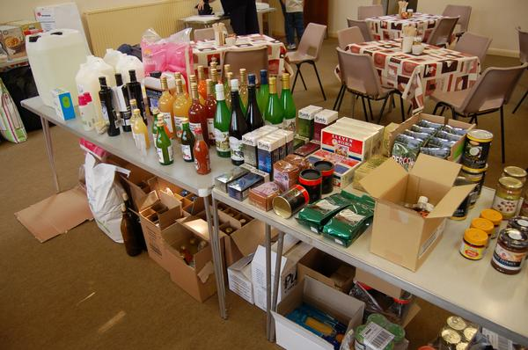
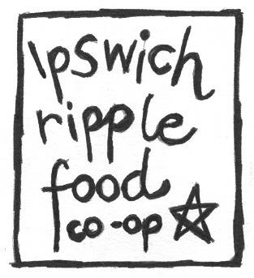
Summary
Ipswich Ripple is a volunteer-run food co-op with had150 members joining in its first year. The food co-op holds stock and operates a fortnightly ‘market’ at a Salvation Army hall selling Suma products, some locally sourced food products and acts as a drop off for River Nene vegetable boxes. The enterprise has incorporated as a Community Interest Company (CIC).

History
Ipswich Ripple food co-op was established in the spring of 2007. On the closure of a local wholefood shop a group of young vegan saw a food co-op as a way of accessing vegan and wholefoods at an affordable price. The founders have a broader vision for how the Ripple initiative might foster sustainable development, and empower the disadvantaged people of Ipswich. This is reflected in its early mission statement - Ripple will promote:
- Community cohesion and cooperation
- Personal wellbeing through education and training
- Affordable services / utilities including retailing of items such as food and clothes
- Accessibility of local community news

In the summer of 2008, Ripple had 150 members, recruited by word of mouth and through the local ‘green’ network.

Governance
Members are a mix of all ages and incomes. They tend to be environmentally aware and are looking to source ecological and ethical products affordably. There are no restrictions to membership, and the co-op is trying to encourage greater local membership especially among the local Portuguese community and those on a low income.

How are decisions made?
With only a year of trading, the co-op has been very much in a developmental phase. Decisions are currently made by an informal steering group – the founding members. This same group also manages the operational aspects of the enterprise with a great deal of support from the wider membership. At the time of this case study the group had not yet had an AGM or formally elected members of the steering group. There are bi-monthly meetings at the Salvation Army hall and all members are welcome, however most members are not involved in the overall strategic direction of the enterprise. Members are kept well informed through e-mail, phone and posters displayed on market days.

Legal form
The founders chose to incorporate as a Community Interest Company (CIC) with co-operative principles because it was cheaper (£35) than incorporating as an Industrial and Provident Society (IPS) and a simpler process. There are 5 directors of the CIC and two signatures are needed for any spending. Currently there is no members' agreement or secondary rules. An application form captures members’ details, and a members’ handbook it being drafted, which includes member obligations and instructions for volunteers.

Although the group aims to be ‘non-hierarchical’, in practice there is currently members are not engaged in the fundamental issues of the enterprises’ development. CIC Memorandum & Articles provide some structure however the group has not yet engaged with issues of governance and has focussed on the practical management of the enterprise. In the long term, the steering group recognises that to share the workload, responsibilities need devolving, and they would benefit from some support to develop their governance.

Finance
The group has received two small grants, £3000 Kick Start, from UnLimited (support for social entrepreneurs) for initial equipment, training, publicity and some initial stock and £700 from ACRE (Suffolk Fund). The group raises revenue to cover operational costs (rent, insurance, etc.) by adding a mark up on wholesale values. They charge an additional 3% for members and 20% for non-members. The group is considering also charging 20% to members that do not contribute time to the enterprise.

Activities
Although the Ripple initiative has broad aims, the principle activity is their fortnightly market held at the Salvation Army hall. Produce at their market is made up largely of Suma products but also includes flour from a local mill, tea from a local packer/distributor, local juices, and home produce – members are encouraged to bring their own produce e.g. honey, herbs, eggs. At the time of writing, approximately 120 items were stocked although these are continuously reviewed. Personal orders can also be made from SUMA catalogue which has thousands of items available. Stock is stored in a secure shipping container on the site. The stock has to be brought out and returned to the container for every trade day which is time consuming.

Customers write pre-orders in an order book on the market day. Orders are consolidated manually, with no invoices raised. A stock check is made at end of each market session, and an order made up for the next market. This is submitted together with customer orders on the Tuesday of the market week. Deliveries are made to the venue on Friday when they are sorted for the Saturday market or personal collection. The markets are open to members and non-members, each having a different pricing arrangement (see finance). In general, items are paid for on collection. There are simple ‘cash box’ checkouts with volunteer cashiers.

All work is voluntary. Members are involved with promotion and running the markets, ordering, etc. The group is considering making member contribution compulsory. Currently it is not and much work is done by same people. The group also organises and supports several social and cultural activities including a café at the Salvation Army hall, a foraging day in local woodland, and bring and share meals.

Future
The group has an ambition to acquire a permanent premises with a café for a social focus - tables to sit at and read catalogues, space for other groups to use e.g. LETS meetings and Green Party. They would also like to develop urban community farm links and do more educational activity to raise awareness about local and sustainable food.

