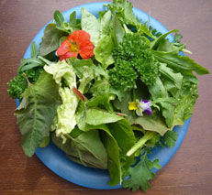
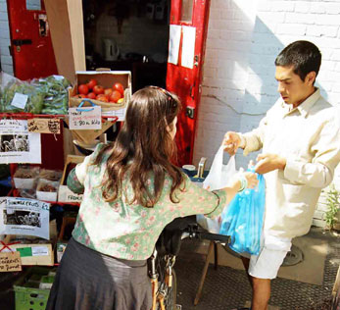

Summary
Growing Communities is a social enterprise run by local people in Hackney, East London. They work to create a sustainable, resilient food system that provides people with good food in a way which cares for the environment and fosters community.

History
Growing Communities was formed in 1996 by local people concerned with the problems of urban communities and environmental degradation and who wanted to help create sustainable solutions to those problems. It grew out of a CSA/Box Scheme that had been set up in 1993, and it also wanted to enable personal, therapeutic and spiritual benefits through reconnecting with food, growing and the seasons.

Growing Communities now has a well established Box Scheme, a Farmers’ Market and manages several urban market gardens. Growing Communities has 12 principles they apply to their enterprise to ensure its sustainability:

The food traded should be:
- Farmed and produced ecologically.
- As local as practicable
- Seasonal
- Mainly plant based
- Mainly fresh and minimally processed
- From small scale operations

And it should be distributed in a way which:
- Supports fair trade
- Involves environmentally friendly and low-carbon resource use
- Fosters community
- Promotes knowledge
- Strives to be economically viable and independent
- Is transparent and promotes trust throughout the food chain

Governance
There are no restrictions to membership, and current members include members of the vegetable box scheme, staff, volunteers and honorary members. Growing Communities has a Management Committee that has legal responsibility for the organisation as a whole. The Management Committee is elected by the members, and makes decisions by consensus and majority voting if necessary. In practice most decisions are made by consensus. The Director reports to the Management Committee, Project Co-ordinators report to the Director. There are 17 part-time staff, which have line management decision making responsibilities. The Management Committee meet quarterly and there are monthly team meetings for staff.

Legal form
Growing Communities is incorporated as a Company Ltd by Guarantee not having share capital and with a voluntary Management Committee. This was chosen to limit liability of the Management Committee. Of the people involved at the time, one wanted be employed and was putting more time into the organisation whilst other members of the founding group were not looking for employment or such a workload, this ruled out the option of a worker co-operative. They also wanted a structure that would leave open the option for charity status though ultimately it was decided charity status was not wanted. Subsequently additional categories of membership have been added to include; Box Scheme members, Community Members, Honorary Members and Staff members, and can now be described as a multi-stakeholder co-operative.

Activities
Growing Communities works with around 40 small local farmers and producers and supply food to over 3000 people each week. They have four areas of work:

- Managing community led sustainable food trading systems – These include a box scheme, a farmers market and a food swap.
- Growing food - Currently run two small urban market gardens in Hackney which supply salads for their box scheme. Areas of work being developed include a Patchwork Urban Farm and Peri-urban Starter Farms.
- Working to inspire and support other communities wanting to learn from their work.
- Carrying out other areas of work as a result of 1, 2 and 3. This may involve campaigning, training, educating, awareness raising or facilitating/networking.

They organise a range of events including cooking demos at the Box Scheme pick up points, events at the Farmers Market (Apple Day, May Day etc) and at the urban market gardens (plant sales, digging days, open days, summer garden party). Members are kept up-to-date through a weekly newsletter in the vegetable boxes.

The Future

They aim to:
- Continue to develop their current projects.
- Further increase the number of farmers and growers and the area of land producing organic food in and around Hackney.
- Use what they have learnt over the last 10 years to increase their impact.

