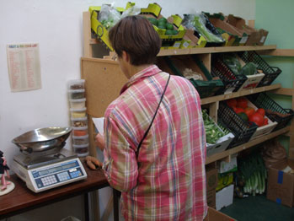
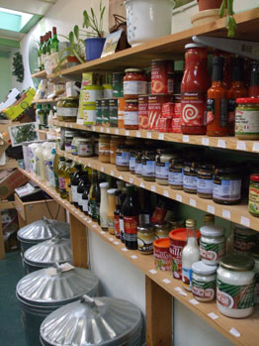

Summary

Bridies Yard Organic Food Co-op based in Glastonbury in Somerset is a large, well-established shop-based co-op offering a wide variety of fresh produce and wholefoods. Members chose and serve themselves their own produce when they visit, then record, add up and pay their own bill. The volunteer team have changed over time but it has been running for 11 years. It is an unincorporated co-operative with a symbolic 1p membership. The co-op is part of a wider community initiative, hosting a range of activities and offering workshop / space for artists, children’s theatre, music and play rehearsals, meetings, and gatherings etc.

History
The original project roots were in a local home educating group and their desire to get families eating healthy food. As with any long-standing project, the aims and project have evolved.

Aims include:
- To supply affordable, healthy, organic food to families and the local community.
- To provide the opportunity for people to network with each other.
- To provide a safe space to explore food issues, including health and sustainability.
- To provide support and encouragement to people wanting to change food habits and explore alternatives (e.g. to wheat or meat).

Volunteers
Different volunteers have brought ideas to the project over time. It is the ongoing commitment of volunteers and the support of members, which keeps the project going. Core volunteers share responsibilities of running all aspects of the co-op, with peripheral volunteers helping out where relevant. Bridies Yard provides opportunities for people to develop their own project ideas. Examples of other products and services offered include pressing and extracting oil from hemp seeds for culinary or medicinal purposes and organic spelt bread and cakes baked on the premises.

Resources
The food co-op has a long-term lease on an industrial unit and bills are covered by a 25% mark-up on produce (recently increased due to a rise in fuel bills). The co-op also offers a direct ordering service which has a 10% mark-up. The project has sourced pieces of equipment over time through resourcefulness and established networks and co-operation. The co-op requests financial donations for events, beverages and soup, which they serve on co-op days, which also contribute to maintenance costs. They have recently acquired and installed a cooker through their contact with a local bread maker.

Promotion

Word of mouth communication has always been key at this project. Different events also draw new people in. They have also produced small flyers in the past and occasional newsletter updates. Bridies Yard also pro-actively networks with other local community groups and support local events to raise their profile.

Achievements
A well-supported food co-op - 645 members over the last 3-4 years and used by 60-70 people per week. The shop stocks over 400 products, requests for particular items are listened to and this is why the range is so diverse. The co-op is keen to support local growers and has been learning how to deal with small-scale producers alongside preventing wastage. The co-op has developed links to other projects, including relationships with other retailers and food buyers to sell-on leftovers. The group have created a kerbside foraging garden from waste ground.

Measuring success
On–going progress and development is reviewed through informal feedback, discussions and reflections on the following:
- Numbers of people engaging
- People joining through recommendation
- Managing financially over time
- Successful community events
- Diverse people involved and included
- Observations of people finding their feet / developing their own ideas and projects
.

Education

The co-op has a food and health notice board where articles, recipes, events can be shared with the wider group. They also keep a small library of information about health concerns and issues and support/encourage discussion on food issues. The shared cooking of soup is a very successful part of the co-op where members can learn how to use different ingredients.

Challenges
Cash flow can be an issue when buying bulk quantities of expensive dried goods – balancing the books is an art form – their good credit rating with Essential helps. Other issues:
- Apparent lack of support / interest from town and district councils
- Lack of time to administer paperwork and funding bids effectively
- Need more skilled support in building maintenance

The Future
The food co-op will continue to be involved in the Transition Glastonbury Food Group and associated events and activities. They are developing links with the local CSA to sell on surplus produce. They are keen to educate children around food production and help them develop an understanding of food growing - from farm to plate. They will continue raising awareness around food issues and would like to offer support and training on running a food co-op. They hope to continue improving facilities in the building and expand their influence to the wider trading estate site they are based upon.

