Growing for Nature:

Biodiversity survey for farms within Greater London

Summary
In Spring/Summer 2024 Capital Growth sought to assess the current state of biodiversity on London’s peri-urban farms. It found that farming in London makes up a variety of land-uses, mainly arable (48%) and horticulture (38%). 18% are mixed farms and only 38% of farms were certified organic. Of the conventional farms, 62% are using herbicides and/or pesticides with arable most likely to be using chemicals than other land-use types.
These peri-urban farms are providing significant habitat for nature, with two-thirds of respondents providing at least one type of habitat. Most common habitat found on these farms are ponds, wildflower meadows and hedges. Woodland and horticulture provided the richest habitat while arable provided the least.
There is a strong appetite for more habitat creation with all of respondents expressing a desire to create more habitat enhancements, with pond building being the most popular followed by hedgerows and wildflower meadows.
Whilst we found that recording wildlife on farms wasn’t that widespread, with no one regularly monitoring nature on their sites, there widespread aspiration to do more with almost all respondents stating that they are already recording nature to some degree or would like to start. Birds, pollinators and plant species were the most commonly monitored categories. The most popular recording initiatives were the RSPB Big Bird Watch and the Big Butterfly Count. Organic farms were recording more species than conventional farms, with a focus on birds, mammals and butterflies.
Over 64% of farms were involved in some kind of biodiversity or conservation scheme, most commonly their local borough’s biodiversity action plan.
Challenges and barrier to doing more to create habitat and monitor were largely around lack of time, money, equipment and expertise.
Background: In May 2024 Capital Growth surveyed farmers in London to gain a clearer understanding of what impact peri-urban farming has on nature and understand the aspirations and challenges farmers face in enhancing biodiversity. The survey was hosted on Survey Monkey and promoted via the Capital Growth newsletters, social media channels and through partners communications. We offered a £400 prize in vouchers to encourage wide participation.

Respondents
The survey had a total of 21 responses, between 1 May and 12 July. The completion rate was 100%.
With approximately 170 farms in Greater London, this sample size represents 12% of London’s farms.

About the food growing spaces in London
All of the participating farms were tenant farmers.
Location: Farms were situated in the outer London boroughs of Barking & Dagenham, Enfield, Greenwich, Kingston, Sutton and Waltham Forest. View map of farm locations
Size of farm
The average size of farm was 190 acres, with the largest farm being 1,100 acres and the smallest 0.5 acres.

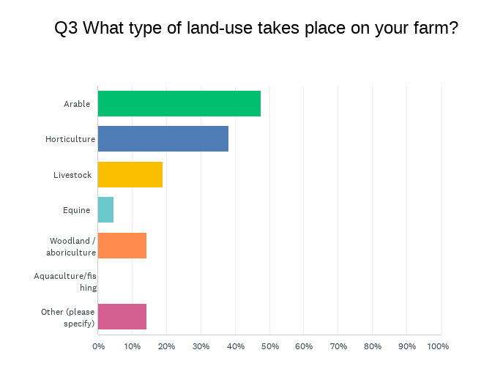
Type of farming
The majority of farms were arable (48%) and horticulture (38%)
Four farms had mixed land-use combining
- Arable & horticulture
- Arable, livestock & horticulture
- Arable & equine
- Horticulture & woodland

What habitats do the farms already provide?
Two thirds of farms provided some habitat for nature. The most common forms of habitat were
- Ponds and wildflower meadows (48% each)
- Hedge management and or new hedge building (38% each)
- Insect boxes/bug hotels (33%)
River and stream restoration and wetlands were the least common habitat being managed. This could be partially due to the geography of the farms in the survey with only a handful being sited on or near waterways.
- Woodland/agriculture provided the richest habitat and arable provided the least.
- Horticulture came a close second with only 12.5% providing none of the listed habitats and hedges being the most common form of habitat followed by meadows. Horticultural farms provided the most variety of habitats compared to other land-use types.
- Third runner up was Livestock farming with 25% providing none of the listed habitats The most common form of habitat found on livestock farms were meadows and hedges.
- Arable farms provided the least habitat for nature with 60% of arable farms providing none of the listed habitats, with wildflower meadows being the most common with 40% providing these.

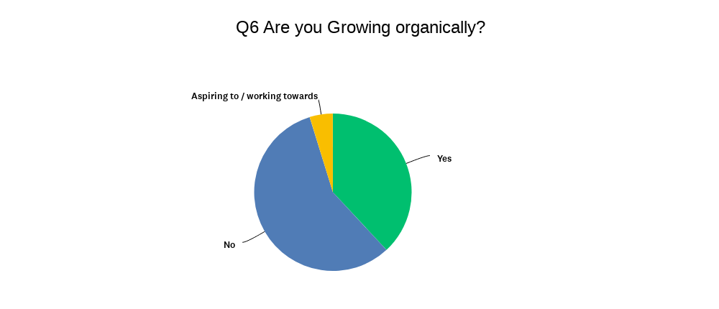
Are they growing organically?
38% of farms are organic and 57% are conventional.
Of the organic farms, these were mosly small farms, with the largest being 160 acres. 75% of organic farms are horticultural operations.
The majority of the conventional farms were arable.

What chemicals are farmers using on their land?
54% were using both pesticides and herbicides.
8% were using pesticides only
The arable farms were most likely to be using pesticides and herbicides on their land with 80% of arable farms surveyed were using herbicides and/or pesticides.

Monitoring wildlife
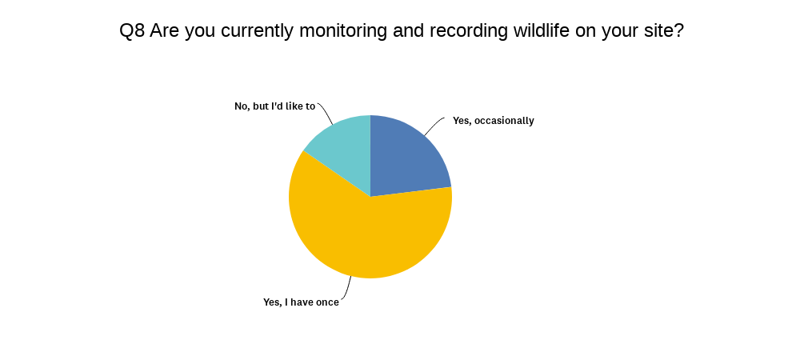
There is a strong interest in monitoring nature among respondents with 100% of respondents saying they have or would like to monitor wildlife on their sites.
None of the farms were regularly monitoring biodiversity on their site but 85% have done occasionally or at least once and 15% have not done so but would like to start. No one said they weren’t interested in this.

What kinds of wildlife are farms monitoring?
Overall, there was not a great variety of wildlife surveys being carried out. The most popular species to be surveyed were birds (26%), plants (26%) and pollinators (21%)
58% of respondents answered “other” to this question. This is because they are participating in the DEFRA Landscape Recovery Scheme which is engaging 12 of the farms within the borough of Enfield in a multi-year large scale rewilding initiative which involves a lot of baseline data collection including soil carbon analysis, plant and wildlife surveys. This data collection is on-going and will be complete in December, and these insights could be shared with us after that point.
Organic farms were more involved in monitoring wildlife than conventional farms. They have monitored:
- Birds (50%)
- Mammals, amphibians, invertebrates (25%)
- Big city butterfly count (25%)
- B-lines - pollinators (12.5%)
- Night Watch - Bats 12.5%
Surprisingly only 16% had monitored soil life, despite this being the foundation and key indicator of biodiversity.

Farms aspirations for more habitat creation
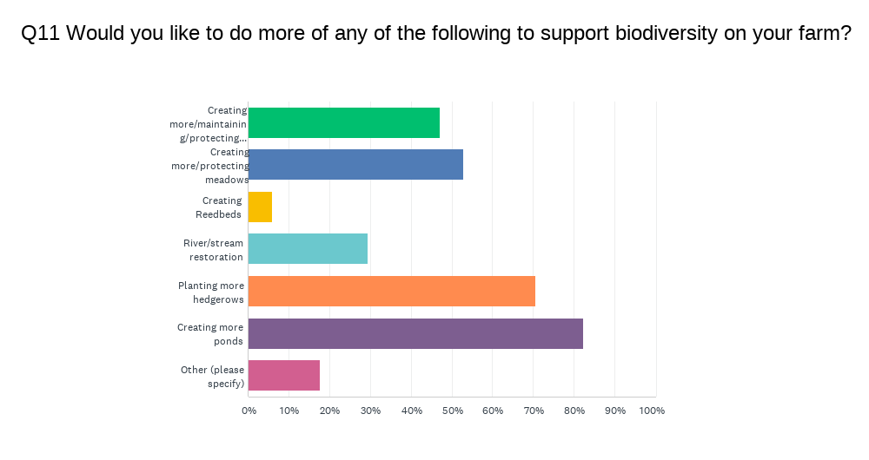
There is a lot of interest in creating more habitat among the farms surveyed.
- Pond building was most popular with 82% of respondents wanting to create more ponds.
- 70% wanted to plant more hedgerows
- 53% wanted to create more or protect existing meadows
- 47% wanted to create more or protect existing woodlands
This was consistent across the different types of land use, with ponds being even more popular with horticultural farms.

What biodiversity initiatives are they already involved in?
There was quite a low engagement in conservation/biodiversity initiatives among survey respondents.
- Local borough’s biodiversity action plan (37.5%)
- Countryside Stewardship or ELMS (25%)

What are the barriers for monitoring, creating and enhancing habitat for nature?
50% of respondents referred to limitations of time, resources and equipment to undertake more monitoring and create more habitat.
50% also stated funding as their main barrier.
Two respondents explained a lack of access to expertise was a barrier to doing more and a need for support from experts who have hands-on experience of rewilding.
“Generally I feel we are getting a lot right and the livestock welfare has to be first. Wouldn't say no to level headed *experienced* expertise and advice - not much time for consultants who haven't actually achieved a broad range of conservation results but are just good at reading and memorising books...”
One comment suggested a more systematised method of recording biodiversity would help:
“No systemic ways to record and monitor different aspects”
This comment suggests that a ‘one-stop-shop’ for entering all your data would be beneficial for busy farmers. There are so many different types of surveys, it can be time consuming to try to engage with more than one at a time.
Also another good point made about habitat creation was needing a steer on what was the most useful thing to do for their locality, “knowing what would be a local benefit”. Local nature recovery strategies have the potential to address this need by providing more bioregional data and plans.

Rachel Dring, Capital Growth Coordinator, Sustain. rachel.dring@sustainweb.org
Capital Growth is London’s leading network for food growers, supporting urban food growers and peri-urban farms to create community, climate and nature resilience. The Growing for Nature project has been developed in partnership with the GLA’s Nature Recovery Team to better understand and enhance biodiversity in London www.capitalgrowth.org

