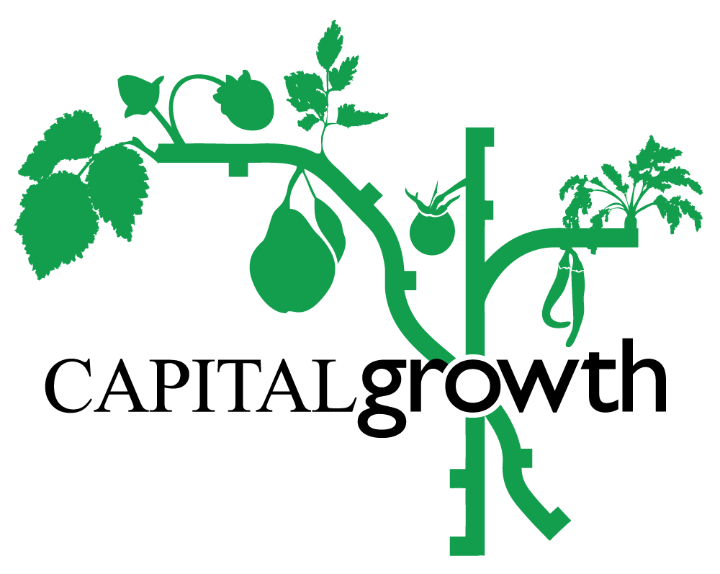

Capital Growth Training Programme 2022

Trainer Application Form
- Spring/Summer Training Application Deadline: 28 February
- Autumn Training Application Deadline: 6 June
- You can expect to hear from us within 7-10 days after the deadline dates for each application cycle
- Application should be sent to: capitalgrowth@sustainweb.org
Thank you for your interest in running a training session with Capital Growth. You’ll find all the necessary information below about our network, training programme and how we plan to run our sessions this year. Please have a careful read through before emailing us your completed form. If you have any questions you’d like to clarify beforehand or would like to request any additional support with completing this application, please reach out to mayya@sustainweb.org.
Our annual Capital Growth Training Programme has been running for many years and we had to swiftly move our sessions online at the start of the Covid-19 pandemic. While we’re always keen to host in-person sessions, many participants also fed back that having online sessions made our training more accessible. Our 2022 programme will therefore blend the two by offering both a mixture of online and in-person sessions, pandemic-permitting.

Training Season 2022
Our 2022 training season will run from March to October and will be divided into a longer Spring/Summer and a shorter Autumn cycle. Spring/Summer training will run from mid-March to end-July and the Autumn training from the beginning of September to end-October with both seasons excluding bank holidays and school breaks.
- According to trainer preference, sessions can be delivered online via Zoom on in-person (pandemic permitting).
- Online sessions can be on Tuesdays, Wednesdays or Thursdays (5.30-7pm).
- In-person sessions can be on Tuesdays, Wednesdays or Thursdays (6-8.30pm) or Saturdays (10.30am-1pm).
- If you feel your in-person session needs to be longer, please let us know and we can discuss further.

Trainer Fee
Our online trainer fee is a sliding scale of between £75-£125 per 1.5 hour online workshop, explained in the table below and based on an open, trust-based approach where our trainers decide where they fall on the fee scale for their session (rather than us suggesting where we think they fall).
Option 1 - £75 | A session that you have done before with slides and requires no prep time.  OR  You are new at delivering training and developing your skills in this area.
Option 2 - £100 | A previously prepared session (or a tried-and-tested CG session) that requires some tweaks or updating for the season or audience (but not extensive prep).
Option 3 - £125 | A brand-new session requiring prep time to create a PowerPoint or gather materials.  AND/OR  An Experienced trainer.

Our in-person trainer fee is £150 per half day workshop.

2022 Training Topics
In line with our latest funding from City Bridge Trust, our focus for this year’s training programme is on the role of community food growing in tackling the nature and climate emergency as well as being inclusive spaces. As such, we ask you to incorporate these themes into your proposed session(s) whether that be in a more focused or broader sense. Examples of themes and specific topics we’ve included in recent years are:
- Food Growing: for beginners, growing indoors, different approaches such as agroecology
- Growing for the future: keeping orchards, taking cuttings and propagating
- Growing for climate resilience: wildlife-friendly gardening, making best use of water in a garden
- Soil Heath: assessing soil quality, making various types of composts and green manures
- People and Plants: how to set up and manage an inclusive garden, how to involve children and schools in gardening

What is expected from a Capital Growth Trainer
- In addition to the information required below as part of this application form, the trainer should provide at least two high-quality pictures with correct credits for Capital Growth to use for promoting the event.
- Delivery of a minimum of one session during the year. Online sessions should include about 15 minutes for questions; in-person sessions should include practical activities (we suggest at least 30 mins for this part).
- The preparation of at least one handout for online sessions.
- The preparation of handouts/presentation materials and equipment on site for in-person sessions.
- Any budget for extra material must be agreed in advance and before the session.

What is expected from Capital Growth
- Help with planning/reviewing training sessions.
- Promotion of the session on multiple social media platforms, mailing lists and
within Capital Growth’s network.
- Management of ticket sales and bookings via Eventbrite.
- Technical support in advance of online sessions (e.g. testing sound,
screen sharing functions, etc.).
- For in-person sessions, we will provide/bring a sign-in sheet for participants.
- Co-hosting and moderation of online sessions.
- Participant feedback using Survey Monkey shared with the trainer.
- Timely payment upon receipt of a correct invoice.

Suggested Training Session
Trainer Name:
Short Bio (Approx. 150 words)
Email:
Contact number:

Which part of the training season are you applying for?
Spring/Summer training ☐
Autumn training ☐
What is your suggested session best suited for?
Online delivery ☐
In person delivery ☐
Either ☐
If you have ticked ‘in-person delivery’ and government restrictions do not allow the gathering of people at the time, could your session be moved online?
Yes ☐
No ☐
If your plan is for an in-person session, are you linked to a growing site that could host your session?
Yes ☐
No ☐
If you answered ‘No’ above, would you need our help with finding a growing site that could host your session?
Yes ☐
No ☐

Suggested dates for the session (please provide at least three suitable options according to session type):
Session Title:
Description (Approx. 250 words) (Concise, clear and catchy):

For in-person sessions: Any extra materials or particular set-up needed?

Thank you for your interest! We look forward to receiving your training proposal!

