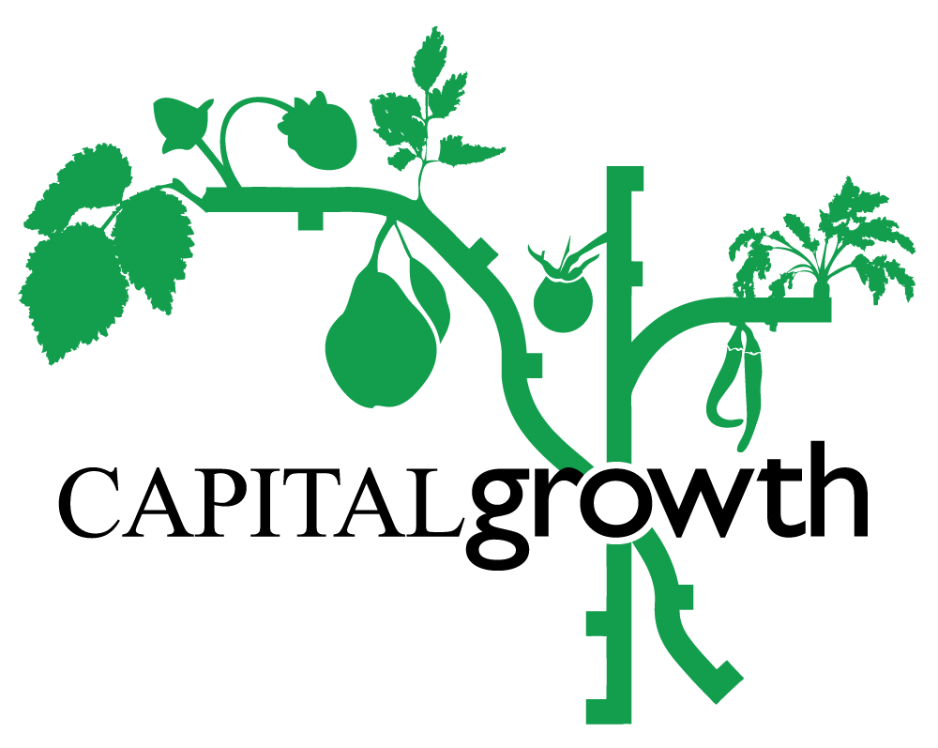

# Capital Growth Training Programme 2025

# Trainer Application Form

* Spring/Summer Training Application Deadline: **Mon 6 January**
* Autumn Training Application Deadline: **Fri** **2 May**
* You can expect to hear from us within 10-14 days after the deadline dates for each application cycle
* Please send your application to: [rachel.dring@sustainweb.org](mailto:rachel.dring@sustainweb.org)

Thank you for your interest in running a training session with Capital Growth. Please have a careful read through before emailing us your completed form. If you have any questions, you’d like to clarify beforehand or would like to request any additional support with completing this application, please reach out to [rachel.dring@sustainweb.org](mailto:rachel.dring@sustainweb.org).

**Please note:** at the time of writing this we are still awaiting confirmation of funding, so there is a chance that we might not be able to go ahead with the 2025 training programme or that it might be delayed. But we are moving forward on the assumption that funding will be confirmed. We will keep you informed of any disruption to these plans.

## Training Season 2025

**Spring/Summer** training will run from March to July

**Autumn** training from September to October

(excluding bank holidays and school breaks).

* Our **in-person sessions** can be on Mondays or Wednesdays from 6-8.30pm or Saturdays/ Sundays from 10.30am-1pm.
* If you feel your in-person session needs to be longer, please let us know and we can discuss further.

## Trainer Fee

Our **in-person trainer fee** is £200 for a 2.5-hour training session inclusive of planning and admin time with extra budget for materials.

## 2024 Training Topics

Our focus for this year’s training programme is on the role of community food growing in tackling the **nature and climate emergency, boosting biodiversity** as well as being **inclusive spaces**. As such, we ask you to incorporate these themes into your proposed session(s) for our Taster Series whether that be in a more focused or broader sense. Examples of requested themes and specific topics fed back from participants and our members:

* Climate resilient systems (e.g. Rainwater harvesting, permaculture, drought resilient crops)
* Specialist growing topics (e.g. crop planning, mushroom cultivation, soil testing)
* Improving biodiversity in your garden (habitat creation, pollinator-friendly planting etc)
* Identifying and recording biodiversity in your garden
* Beginners’ food growing skills (e.g. container growing, winter veg, understanding soil)
* Tool care and tool sharpening
* Food growing in schools
* Garden design and closed loop systems
* Soil health / soil testing / composting
* Companion planting
* Growing legumes specifically for drying
* Forest farming
* How to work with London heavy clay soil
* Plant pest and disease management

## Who is the training aimed at?

We will run two levels of workshops:

**Taster series:** more introductory sessions for beginners and people just getting started

**Masterclass series:** for more experienced food growers, offering more specialist topics

When applying please specify whether you’d like to lead a Taster or Masterclass session

## What is expected from a Capital Growth Trainer

* In addition to the information required below as part of this application form, the trainer should provide at least two high-quality pictures with correct credits for Capital Growth to use for promoting the event.
* In-person sessions should include practical activities (we suggest at least 30 mins for this part).
* The preparation of handouts/presentation materials that can be printed out for attendees and/or circulated after the session.
* The preparation of equipment needed on site during the in-person sessions.
* Any budget for extra material must be agreed in advance and before the session.
* If for whatever reason, government restrictions do not allow the gathering of people, we will explore whether the session could be moved online.

## What is expected from Capital Growth

* Help with planning/reviewing training sessions.
* Promotion of the session on multiple social media platforms, mailing lists and

within Capital Growth’s network.

* Management of ticket sales and bookings via Eventbrite.
* We will provide/bring a sign-in sheet for participants.
* Participant feedback using Survey Monkey shared with the trainer.
* Timely payment upon receipt of a correct invoice.

## Suggested Training Session

|  |  |
| --- | --- |
| **Trainer name:** |  |
| **Short bio (Approx. 150 words)** |  |
| **Email:** |  |
| **Contact number:** |  |

**Which part of the training season are you applying for?**

Spring/Summer training

Autumn training

**What level of experience is your session aimed at?**

Beginners/taster session

Masterclass session

**Are you linked to a growing site that could host your session?**

Yes

No

**If you answered ‘No’ above, would you need our help with finding a growing site that could host your session?**

Yes

No

|  |  |
| --- | --- |
| **Suggested dates for the session (please provide at least three suitable options according to session type):** |  |
| **Session title:** |  |
| **Description (Approx. 250 words)** *(activities, learning topics covered)* | |
| **Any materials or particular set-up needed?** | |

**Thank you for your interest! We look forward to receiving your training proposal!**