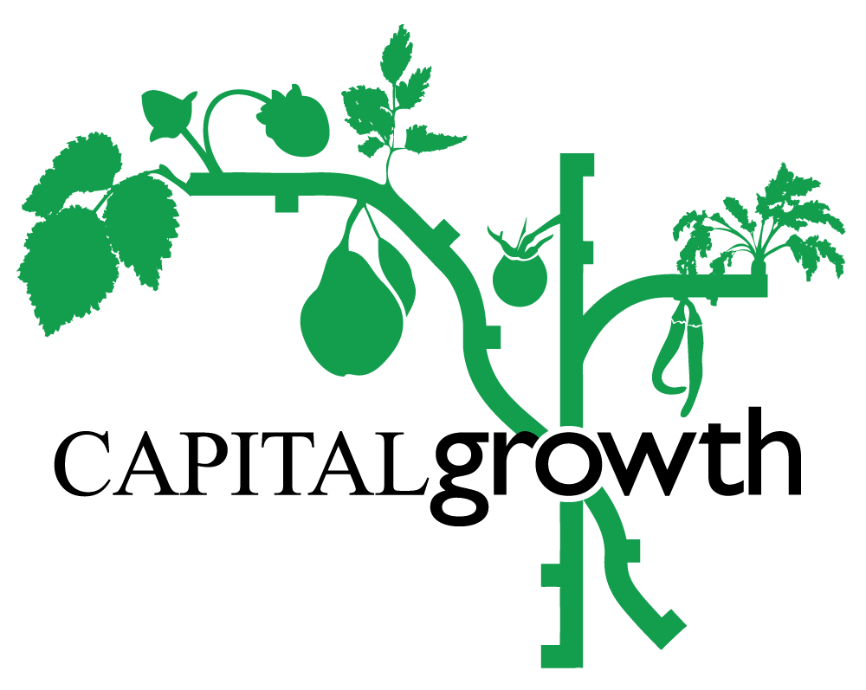

Capital Growth training programme 2023

Trainer application form
- Spring/Summer Training Application Deadline: Fri 18 February
- Autumn Training Application Deadline: Fri 9 June
- You can expect to hear from us within 7-10 days after the deadline dates for each application cycle
- Please send your application to: mayya@sustainweb.org
Thank you for your interest in running a training session with Capital Growth. You’ll find all the necessary information below about our network, training programme and how we plan to run our 2023 training season. Please have a careful read through before emailing us your completed form. If you have any questions you’d like to clarify beforehand or would like to request any additional support with completing this application, please reach out to mayya@sustainweb.org.
Our annual Capital Growth Training Programme has been running for many years and we had to swiftly move our sessions online at the start of the Covid-19 pandemic. Last year, as restrictions lifted, we were able to begin hosting some in-person training alongside online sessions. This year, we’re going back to exclusively hosting in-person sessions based on participant having feedback.

Training Season 2023
Our 2023 training season will run from March to October and will be divided into a longer Spring/Summer and a shorter Autumn cycle. Spring/Summer training will run from mid-March to end-July and the Autumn training from the beginning of September to end-October (excluding bank holidays and school breaks).
- In-person sessions can be on Tuesdays and Wednesdays from 6-8.30pm or Sundays and Saturdays from 10.30am-1pm.
- If you feel your in-person session needs to be longer, please let us know and we can discuss further.
As part of this year’s training season, we will be piloting our Masterclass series through four training sessions with veteran trainers from our network delivering one in-depth session a month from March to June. Trainers have already been identified for these sessions and they will be aimed at those who already have experience with food growing on the following topics:
- Composting
- Understanding the soil food web to maximise yield
- Water-efficient irrigation techniques
- Forest garden design

As well as our Masterclass series, we will also be running our Taster Series with food growing training topics listed below.

Trainer Fee
Our in-person trainer fee for our Taster Series is £175 per half day training session (updated from our 2022 fees to keep in line with inflation rates at the time of drafting this).

2023 Training Topics
In line with our latest funding from City Bridge Trust, our focus for this year’s training programme is on the role of community food growing in tackling the nature and climate emergency as well as being inclusive spaces. As such, we ask you to incorporate these themes into your proposed session(s) for our Taster Series whether that be in a more focused or broader sense. Examples of requested themes and specific topics fed back from participants who attended our training session last year are:
- Tool care and tool sharpening
- Growing according to school term times
- Garden design and closed loop systems
- Soil health
- Companion planting
- Growing legumes specifically for drying
- Forest farming
- Drought resilient crop varieties
- How to work with London heavy clay soil
- Plant pest and disease management
- Mushroom cultivation

What is expected from a Capital Growth Trainer
- In addition to the information required below as part of this application form, the trainer should provide at least two high-quality pictures with correct credits for Capital Growth to use for promoting the event.
- In-person sessions should include practical activities (we suggest at least 30 mins for this part).
- The preparation of handouts/presentation materials that can be printed out for attendees and/or circulated after the session.
- The preparation of equipment needed on site during the in-person sessions.
- Any budget for extra material must be agreed in advance and before the session.
- If for whatever reason, government restrictions do not allow the gathering of people, we will explore whether the session could be moved online.

What is expected from Capital Growth
- Help with planning/reviewing training sessions.
- Promotion of the session on multiple social media platforms, mailing lists and
within Capital Growth’s network.
- Management of ticket sales and bookings via Eventbrite.
- We will provide/bring a sign-in sheet for participants.
- Participant feedback using Survey Monkey shared with the trainer.
- Timely payment upon receipt of a correct invoice.

Suggested Training Session
Trainer name:
Short bio (Approx. 150 words)
Email:
Contact number:

Which part of the training season are you applying for?
Spring/Summer training ☐
Autumn training ☐

Are you linked to a growing site that could host your session?
Yes ☐
No ☐

If you answered ‘No’ above, would you need our help with finding a growing site that could host your session?
Yes ☐
No ☐

Suggested dates for the session (please provide at least three suitable options according to session type):

Session title:
Description (Approx. 250 words) (Concise, clear and catchy):

Any extra materials or particular set-up needed?

Thank you for your interest! We look forward to receiving your training proposal!

